Project Design Phase-II
Data Flow Diagram & User Stories
Field | Details
Date | 01 October 2026
Team ID / Student Name | Priyadharshini S
Project Name | Auto Ticket Classification using Flow Designer
Maximum Marks | 4
Data Flow Diagrams (DFD)
A Data Flow Diagram (DFD) is a traditional visual representation of the information flows within a system. It graphically depicts system requirements by showing how data enters and leaves the system, what changes the information, and where data is stored.
System Components & Architecture
1. External Entities (Users / Systems)
- Caller (Student / Teacher): The end-user who submits an IT support ticket.
- IT Helpdesk Agent / Admin: The user who manages the system and resolves classified tickets.
2. System Processes
- 1.0 Ticket Creation: The caller submits basic ticket details (Caller Name, Short Description) via the Incident WorkFlow form.
- 2.0 Keyword Analysis & Auto-Classification: Flow Designer evaluates the Short Description for specific keywords (Wi-Fi, Projector, Password, Slow) to automatically assign the correct Category and Subcategory.
- 3.0 Email Notification Generation: Flow Designer dynamically fetches the caller's email and sends an outbound confirmation message.
3. Data Stores (Databases)
- D1 Custom Table (Incident WorkFlow): Stores ticket details including Ticket Number, Caller Name, Category, Subcategory, Short Description, and State.
- D2 User Table (sys_user): Stores user profile information and caller email addresses.
- D3 System Email Log (sys_email): Stores records and audit logs of all sent outbound confirmation emails.
Data Flow Process (Diagram Representation)
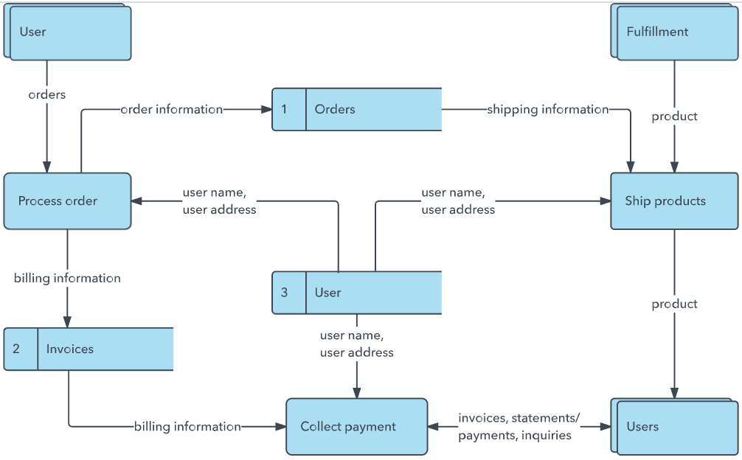
Plaintext
[ External Entity: Caller / Student ]
|
| 1. Submits Ticket Details (Caller Name, Short Description)
v
( Process 1.0: Ticket Creation Form )
|
| 2. Saves New Ticket Record
v
[ Data Store D1: Incident WorkFlow Table ]
|
| 3. Triggers Flow (Record Created & Category is Empty)
v
( Process 2.0: Flow Designer Keyword Classification )
|
|-- Reads Short Description Keywords (WiFi / Projector / Password / Slow)
|-- Fetches Caller Email from [ Data Store D2: sys_user Table ]
|
| 4. Updates Ticket Record with Category & Subcategory
v
[ Data Store D1: Incident WorkFlow Table ]
|
| 5. Triggers Outbound Email Notification
v
( Process 3.0: Outbound Email Engine )
|
| 6. Logs Email Record in [ Data Store D3: sys_email Table ]
v
[ External Entity: Caller's Email Inbox ]
User Stories
Below is the user story mapping table for the Auto Ticket Classification system:
User Type DOCX | Functional Requirement (Epic) DOCX | User Story Number DOCX | User Story / Task DOCX | Acceptance Criteria DOCX | Priority DOCX | Release DOCX
Caller (Student/Teacher) | Ticket Creation | USN-1 | As a Caller, I want to submit an IT ticket by entering only my Name and Short Description, so that I don't need to manually guess the category. | Ticket is saved successfully in Incident WorkFlow table with an auto-generated Number. | High | Sprint-1
Caller (Student/Teacher) | Email Confirmation | USN-2 | As a Caller, I want to receive an immediate email confirmation upon ticket creation, so that I know my issue has been logged. | Automated confirmation email is received containing ticket details. | High | Sprint-1
IT Helpdesk Agent | Auto Classification | USN-3 | As an IT Agent, I want the system to auto-classify tickets based on keywords like "WiFi", "Projector", "Password", or "Slow", so that manual categorization effort is reduced. | Category and Subcategory fields are automatically populated upon record save based on flow rules. | High | Sprint-1
IT Helpdesk Agent | Choice Field Dependency | USN-4 | As an IT Agent, I want the Subcategory choices to dynamically filter based on the Category, so that invalid category-subcategory combinations are avoided. | Selecting 'Network' only shows 'Wi-Fi' in subcategory; selecting 'Hardware' only shows 'Projector'. | Medium | Sprint-1
Administrator | Lifecycle & Update Set Management | USN-5 | As an Admin, I want all configuration changes captured inside a custom Update Set, so that I can export the application as an XML file for deployment. | Project Update Set captures custom table, flow, choices, and exports cleanly to XML. | High | Sprint-2

